**MACHINE INTELLIGENCE**

**SRN :PES2UG21CS423**

**NAME :RANJITHA S K**

**SECTION:G**

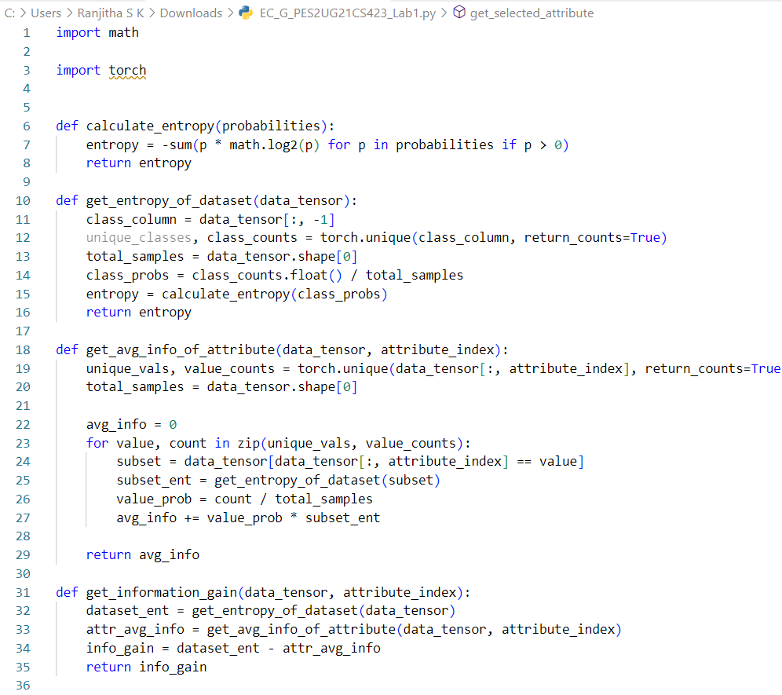

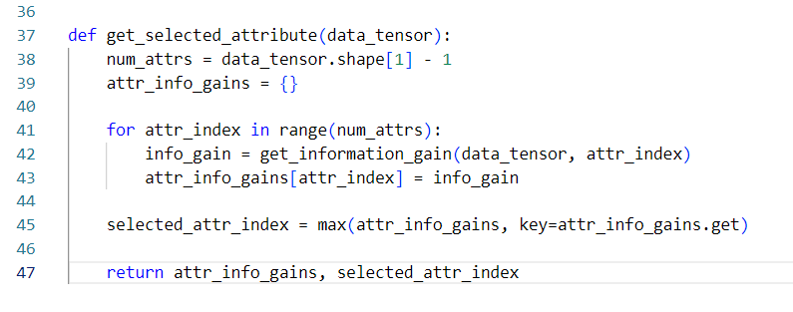

**OUTPUT**

